20th June 2024
Dear Pharmacy Contractor
Re: Outcome of the Special Meeting of Contractors to vote on merging with Community Pharmacy Swindon and Wiltshire

Proposals to update the LPC model constitution and in parallel for contractors to consider the future size and footprint of their LPC(s) were made by the Review Steering Group (RSG) and supported by an overwhelming majority of community pharmacy contractors in a national vote in June 2022. A review by Community Pharmacy Avon (CPA) at the time, recognised that the current LPC was not coterminous with the ICB as CPA represents BANES contactors which sits in BSW ICB along with all the BNSSG ICB pharmacies.

Following this review, CPA opened dialogue with Community Pharmacy Swindon and Wiltshire (CPSW) in relation to a merger to allow a newly formed LPC to meet the contractor size recommendation, and to represent contractors across two full ICB footprints; BSW and BNSSG. An SGM was held on Tuesday 18th June at the request of the CPA committee and sought your approval by ballot of pharmacy contractors to proceed with the merger.

At the CPA SGM a unanimous vote from contractors approved the motion for CPA to merge with CPSW and create a new LPC covering both BSW and BNSSG ICBs. A simultaneous SGM was held also by CPSW, with the proposal to merge also carried by a unanimous vote.

The two committees will now work together to deliver the practical steps needed during this transitional phase, with the aim of the merger process completing ready for the start of the new financial year in April 2025. Any subsequent constitutional changes that will be needed will be submitted to contractors for approval at a future SGM as per the current constitution. The expected timeline is shown below:

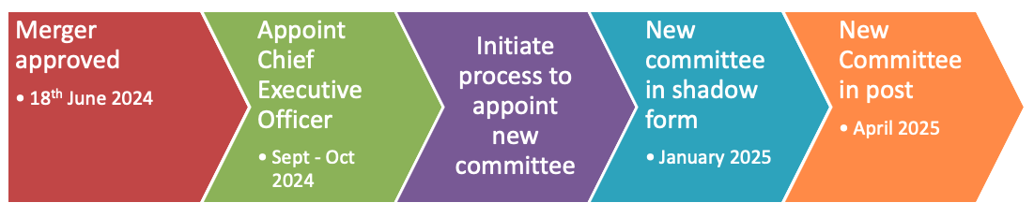

The representation and support functions of each LPC will continue as usual in the interim period. If you wish to have a conversation about the result or have any queries during this transitional phase please contact the CPA Chair, Lisa Fisher, who would be happy to discuss.

Kind regards,

Richard

Richard Brown,
Community Pharmacy Avon
Chief Officer

