Targeted Support to Stop Smoking Service in Bristol

  - Evidence Summary

Evidence Summary
Contents
Decline in Smoking prevalence 3
Decline in uptake of current services 3
Support used in quit attempts 4
Smoking in Pregnancy 5
Long Term Conditions and NHS Health Checks 6
Telephone and Digital Support 6

Prepared by
Andrea Dickens
Principal Public Health Specialist
Bristol City Council
2020

Decline in Smoking prevalence
There has been a steady decline in smoking prevalence both nationally and in Bristol since 2011.

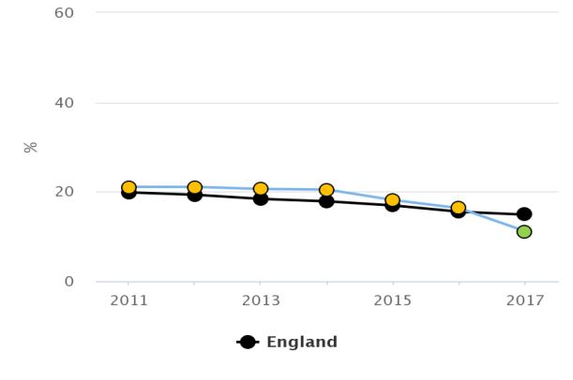

Smoking in adults (18+) prevalence trend data for Bristol: PHE Fingertips Local Authority Profiles

Decline in uptake of quit services

Nationally, there has been a steady decline in numbers accessing support to stop services since the peak of 2011/12. In 2017/18 setting a quit date fell for sixth consecutive year a decrease of 11% on 2016/17

In line with the national trend, the rate of successful quitters at 4 weeks per 100,000 smokers in Bristol has continued to fall (1,538 per 100,000 in 2016/17). Bristol remains significantly lower than the national average rate for smoking quitters (2,248 per 100,000).

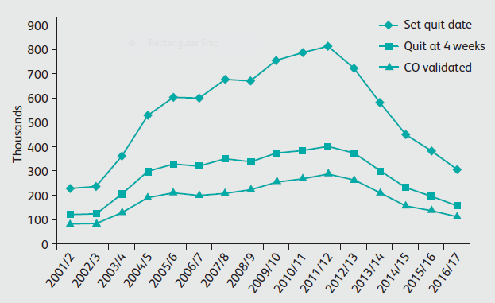

Number of smokers setting a quit date, and self-reported and CO validated quitting at 4 weeks, in NHS Stop Smoking Service in England from 2001/2 to 2016/17. Royal College of Physicians: Hiding in Plain Sight. 2018

The reduction in recent years may be in part due to the rise in the popularity of vaping which is now the most popular quitting method. Nicotine delivered through vaping is the most popular pharmacotherapy, with a subsequent reduction in over the counter stop smoking medicines and NRT.

Support used in quit attempts

There has been a steady shift in the pharmacotherapies used by smokers wanting to stop and the methods of accessing them. This is also a reflection of the decline in uptake of traditional support to stop services.

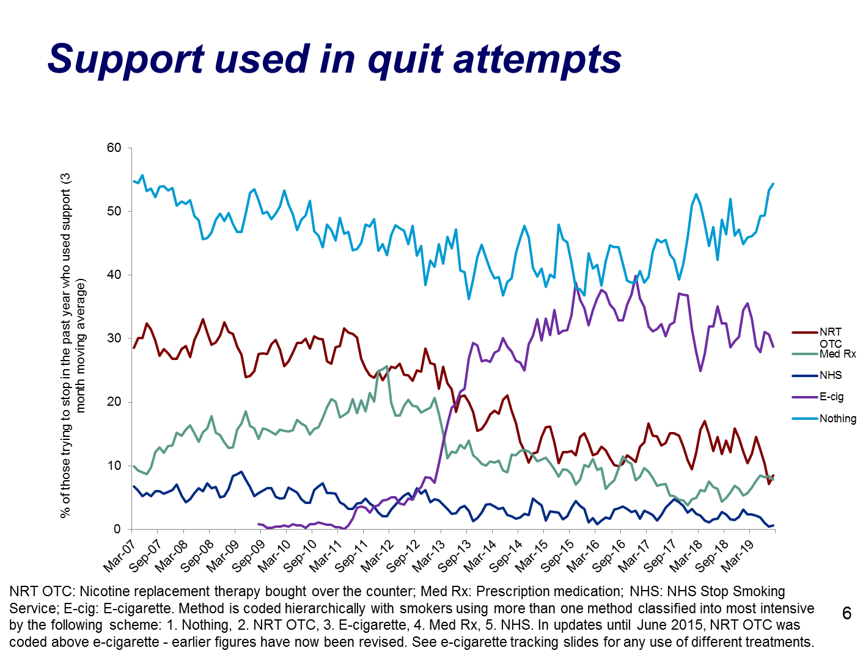

Public Health England maintains that vaping is “at least 95% less harmful than smoking cigarettes”, and has not changed its advice on nicotine containing e-cigarettes “Smokers should consider switching completely and vapers should stop smoking”

Recent evidence from a randomised controlled trial showed that vaping was nearly twice as effective as NRT in helping smokers quit in a Stop Smoking Service setting in England¹.

In the first half of 2017, quit success rates in England were at their highest rates so far observed and for the first time, parity across different socioeconomic groups was observed. It is plausible that e-cigarettes have contributed to this. Using e-cigarettes to quit, or as an aid to keep them off tobacco, was the reason most frequently given for vaping amongst ex-smokers who are also ex-vapers (38% and 20% respectively).

Smoking in Pregnancy

The overall rate of Smoking at Time of Delivery (SATOD) for Bristol has been relatively static since 2010/11. (Public Health Outcomes Framework (PHOF) Trend data). The current rate is in line with national figures. This represents nearly 600 women a year smoking during pregnancy.

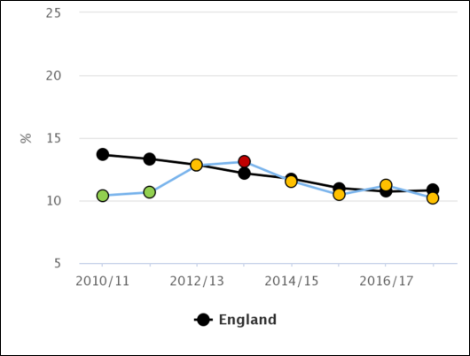
SATOD trend data for Bristol– PHE Fingertips: Local Authority Public Health Profiles 2019

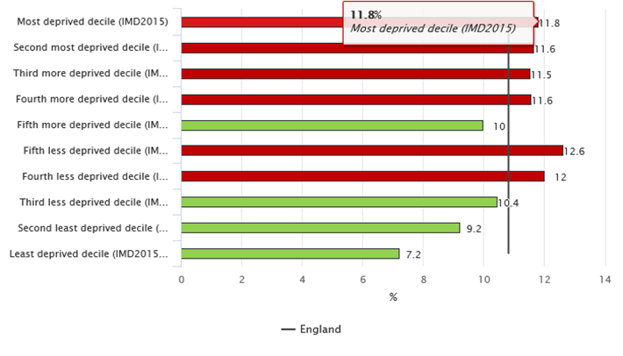
SATOD by Deprivation Decile– PHE Fingertips: Local Authority Public Health Profiles 2019

The Smoking in Pregnancy Challenge Group produced an updated Review of the Challenge in 2018. This highlighted the gap between the current levels of smoking at time of delivery and the national ambition of 6% SATOD by 2022. To achieve this, Bristol will need to almost half SATOD in three years. The existing approaches would not achieve this, supporting the need for a more targeted approach.

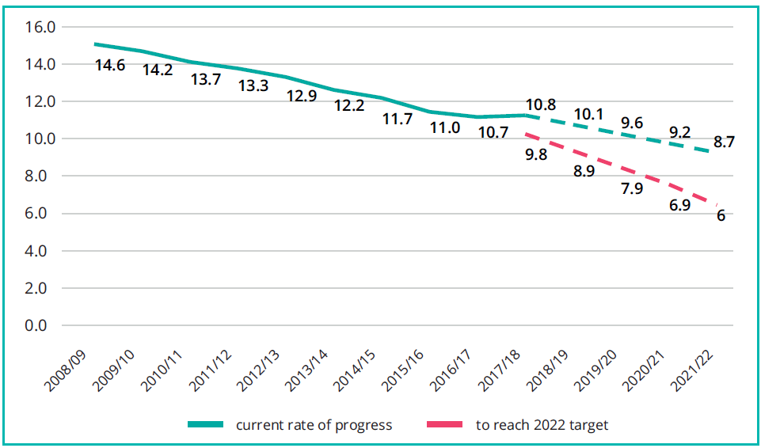
Smoking in pregnancy: Progress needed to achieve 2022 national ambition.
Smoking in Pregnancy Challenge Group. Review of the Challenge 2018

The first 1000 days of life, from conception to age 2, is a critical phase during which the foundations of a child’s development are laid. The influence of a child’s parents during these early years cannot be overstated. A child’s health and development is influenced by their parents’ behaviours, including that of smoking. Michael Marmot’s review of health inequalities in 2010 stressed that “what happens in these early years, starting in the womb, has lifelong effects” on a person’s health, wellbeing and life chances.

The new service will provide whole family support for pregnant smokers, with the most intensive evidence-based face to face support for this priority group. It will not be restricted to pregnancy only but will provide support up to the first 1000 days of life, recognising the need for support to prevent relapse post-partum and ensure quitting is sustained.

We are aware that a commonality across Smoking in Pregnancy Services is the tendency for women who have managed to quit smoking during pregnancy to recommence smoking post-birth, and for women who significantly reduced their smoking whilst pregnant to increase their smoking again. The service will aim to address this issue. Reducing smoking in pregnancy will significantly reduce numbers of preterm births and babies with low birth weight, and reduce still births, neonatal deaths and sudden infant deaths.

Long Term Conditions and NHS Health Checks
The Public Health England ‘Local Health and Care Planning -Menu of Preventative Interventions’ identified the biggest short term savings opportunity lies in helping smokers who are in contact with the NHS, through screening, advice and referral in secondary care. This was reported to provide a net saving in 5 years. The service will provide a seamless transition to community based support on discharge from hospital, optimising the ‘teachable moment’ opportunity and in line with the CQUIN and NHS Long Term Plan. The service will also provide support to adults who want to stop smoking after receiving an NHS Health Check, in line with Public Health England’s Cardiovascular Disease Ambitions and the NHS Long Term Plan.

Telephone and Digital Support
While the evidence base is not currently as strong interventions using SMS text messaging and digital apps as it is for traditional in-person and group methods of delivering smoking cessation support, these are new technologies and the evidence base is growing with time. Telephone support in particular is a promising new avenue for the delivery of personalised smoking cessation behavioural interventions and represents a responsive and cost effective method of supporting quitters,,. The new service will be able to support a larger number of smokers to quit through telephone and digital support whilst at the same time being responsive to the change in usage of support to stop reflected in the current evidence and practice¹.

NHS Smokefree has a range of support signposted from the NHS Smokefree website (https://www.nhs.uk/smokefree/help-and-advice/support). This includes the smartphone app, email programme which provides a personal quit plan or text messages along with the free Smokefree National Helpline (0300 123 1044) staffed by trained , expert advisers, as well as the online chat option available through the app. The value of online self-help approaches is supported by Public Health England’s broad support for digital methods, and compliments the most popular method of quitting smoking – self-help without engaging with a service.

Hajek, P..Phillips-Waller, A.. et al. 2019 A Randomized Trial of E-Cigarettes versus Nicotine-Replacement Therapy. N Engl J Med 2019; 380:629-637
https://www.gov.uk/government/news/phe-publishes-independent-expert-e-cigarettes-evidence-review
Evidence review of e-cigarettes and heated tobacco products - McNeill A, Brose LS, Calder R, Bauld L & Robson D (2018)
https://publichealthmatters.blog.gov.uk/2019/10/29/vaping-and-lung-disease-in-the-us-phes-advice/
Smokefree GB, carried out for ASH by YouGov Spring 2019 https://ash.org.uk/information-and-resources/fact-sheets/statistical/use-of-e-cigarettes-among-adults-in-great-britain-2019/
House of Commons Health and Social Care Committee First 100 Days of Life, 2019
Marmot M, Allen J, Goldblatt P et al (2010) Fair society, healthy lives: strategic review of health inequalities in England post 2010. Department of Health. London
The Cochrane Collaboration. 2019. Telephone counselling for smoking cessation (Review 2) 2019. http://www.thecochranelibrary.com Whittaker, R; McRobbie, H; et al. 2016. Mobile phone-based interventions for smoking cessation. Cochrane Database of Systematic Reviews. 2016. Issue 4. http://www.thecochranelibrary.com
Stead, LF; Perera, R; Lancaster, T. 2009. Telephone counselling for smoking cessation (Review) The Cochrane Library 2009, Issue 3. http://www.thecochranelibrary.com
Whittaker, R; McRobbie, H; et al. 2016. Mobile phone-based interventions for smoking cessation. Cochrane Database of Systematic Reviews. 2016. Issue 4. http://www.thecochranelibrary.com

