3rd July 2019
Dear Colleague,
We have been supplying Unity Chlamydia Screening kits in the pink and blue shiny bags for some time and we need to look at a slightly cheaper and less gender stereotyped way of delivering these.
From August 2019 the kits will be provided in plain white paper bags that will be sealed with one of the two stickers below to indicate whether they contain a vaginal swab or urine collection kit.
The kit expiry date will be printed along the yellow edge of the sticker.
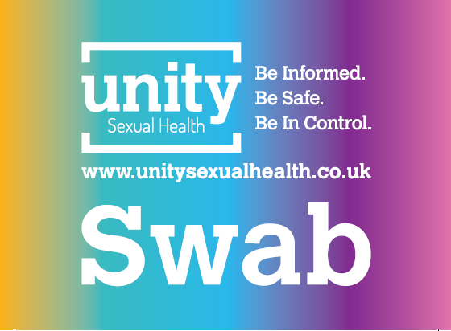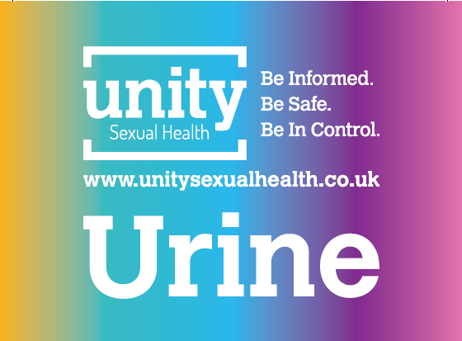

Since we moved over to the Unity Seual Health service 2yrs ago, we have been coordinating the postal kits that arerequested via the Unity website https://www.unitysexualhealth.co.uk/test-kit/. These offer tests for Chlamydia and Gonorrhoea, and also, blood taking kit for HIV and Syphilis screening.
This is also an option to offer your clients rather than you having to request and stock the Chlamydia Screening packs.
Please contact me if you have any questions.
Best wishes
Karl
Karl Liva-Pye
Team Manager – Chlamydia Screening
Unity Sexual Health Services
0117 342 9299
