Accessing Summary Care Record
Ensure you are signed in with your smartcard and go to https://portal2.national.ncrs.nhs.uk/summarycarerecord
You search by entering either Gender, Surname, and Date of Birth, OR by entering NHS Number:
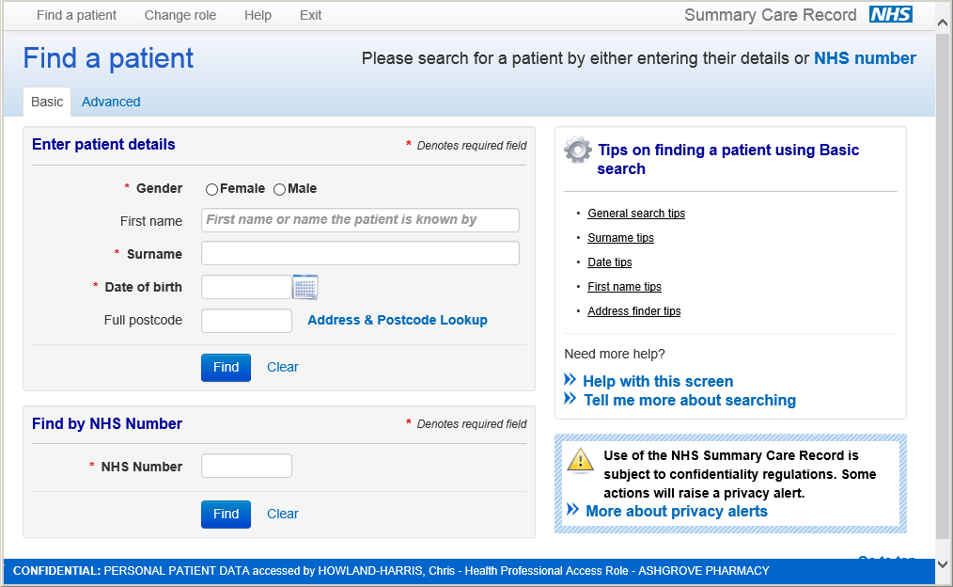

When you press find you will see the patient info (NB – if telephone number is recorded you can view this without accessing SCR):
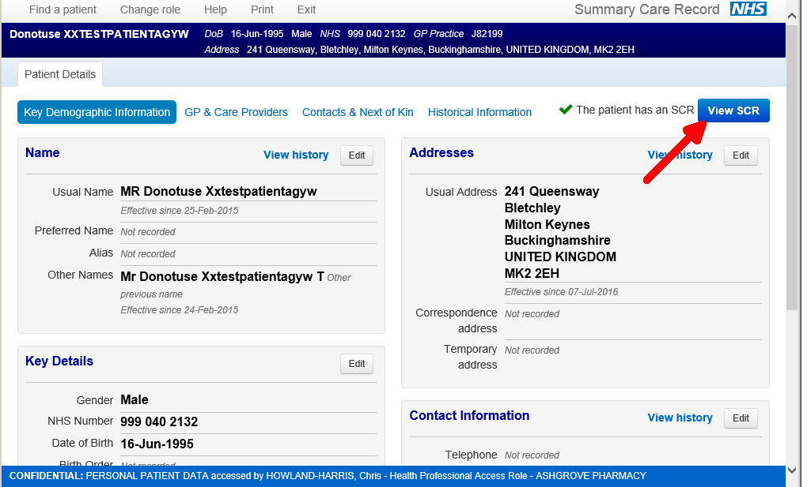
When you click “View SCR” you are presented with this screen. If the patient has given explicit permission (this does not have to be for every occasion – you may wish to record SCR permission in patient’s PMR) click “Yes”. If patient hasn’t given explicit permission but it is in their best interest to access you click “No” and record the circumstances.
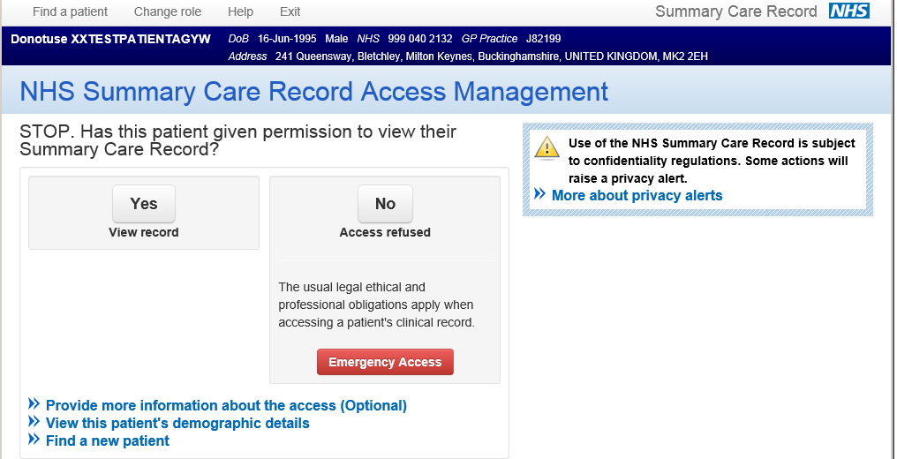

You are then presented with the Summary Care Record which includes allergies and adverse drug reactions, and any prescriptions (paper or electronic scripts) issued by the doctor as Acute, Repeat, or those that have been stopped and moved to Past Drugs:
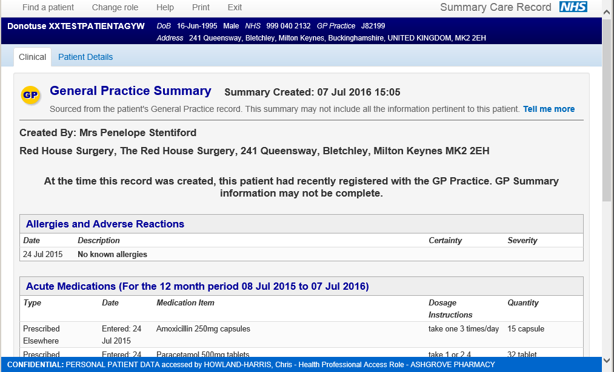

Accessing the Privacy Officer role:
Ensure you are signed in with your smartcard and go to https://portal.national.ncrs.nhs.uk/portal/dt Click on the “Launch Alert Viewer:
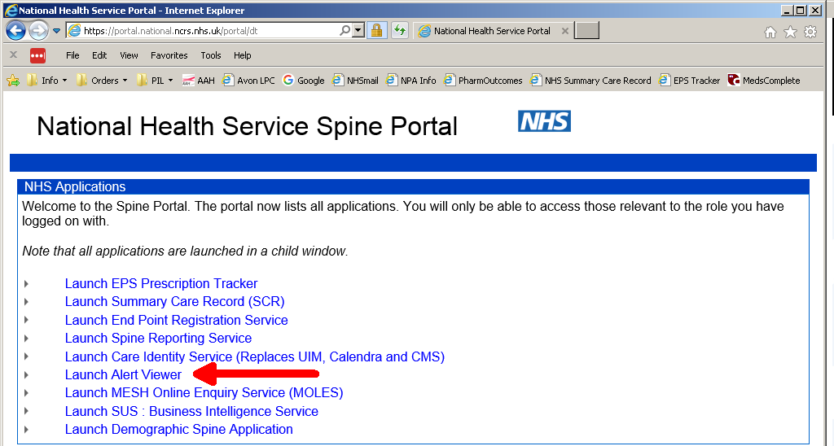

Next click in circle to select your privacy officer role and click continue:
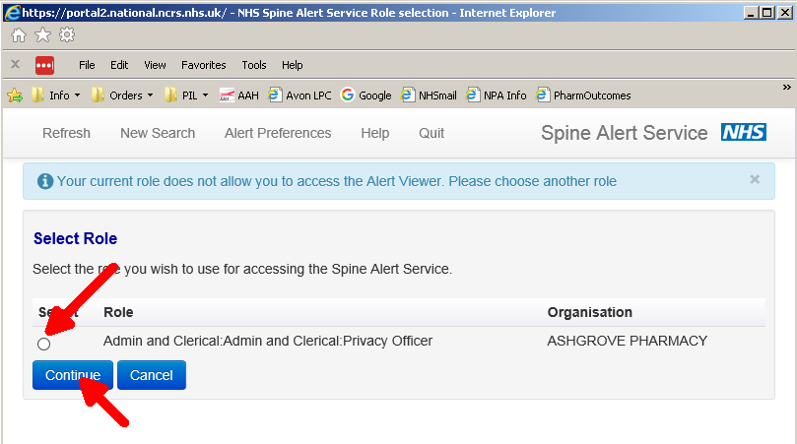

You are then presented with the alert search list:
